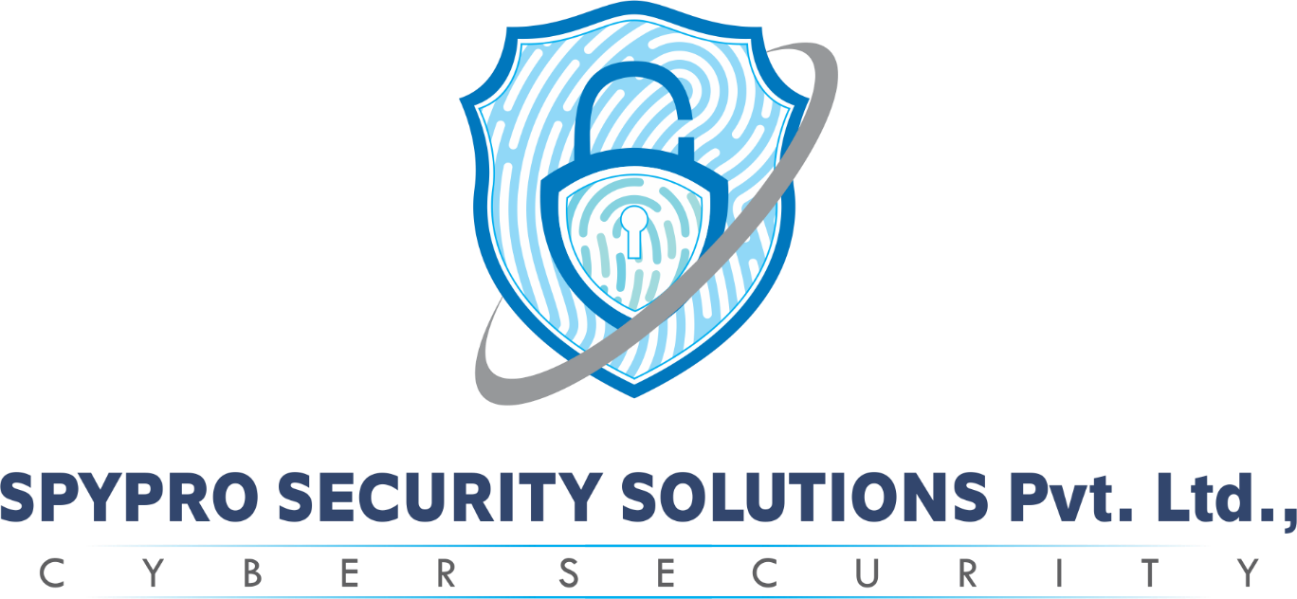
5-Days Workshop on Cisco Hardware and Networking

The CCNA (Cisco Certified Network Associate) Networking 5-day workshop is an intensive training program designed to equip participants with the fundamental knowledge and skills required to work with Cisco networking technologies. This workshop is targeted at individuals who are interested in starting a career in networking or professionals seeking to enhance their networking expertise.

Topics to be covered in Cisco Hardware and Networking

Day 1: Introduction to Networking and Cisco Devices
- Overview of computer networks and the OSI model
- Introduction to Cisco networking devices (routers, switches)
- Basic configuration of Cisco devices using the command-line interface (CLI)
- Configuring IP addressing and subnetting
- Introduction to routing protocols (e.g., RIP, OSPF)

Day 2: LAN Switching and VLANs
- Understanding Ethernet LANs and basic switching concepts
- Configuring VLANs (Virtual Local Area Networks)
- Inter-VLAN routing using routers and Layer 3 switches
- Configuring VLAN Trunking Protocol (VTP)
- Understanding Spanning Tree Protocol (STP) and its variants

Day 3: IP Routing and Dynamic Routing Protocols
- Overview of IP routing
- Configuring static routing
- Introduction to dynamic routing protocols (e.g., RIP, OSPF, EIGRP)
- Configuring dynamic routing protocols
- Understanding routing metric and administrative distance

Day 4: Network Services and WAN Technologies
- Introduction to network services (DHCP, DNS, NAT, ACLs)
- Configuring DHCP (Dynamic Host Configuration Protocol)
- Implementing network address translation (NAT)
- Understanding access control lists (ACLs) and their configuration
- Overview of WAN (Wide Area Network) technologies (e.g., PPP, Frame Relay)

Day 5: Network Troubleshooting and Security
- Network troubleshooting methodologies and tools
- Troubleshooting common network issues
- Introduction to network security principles
- Implementing basic network security measures (e.g., password encryption, securing remote access)
- Overview of network security threats and countermeasures

Duration: The duration of this workshop will be three consecutive days, with 6 hour session each day in a total of 30 hours properly divided into theory and hands on practicals sessions.

Certification Policy:

- Certificate of Merit for all the workshop participants from SmartBridge.
- At the end of this workshop, a small competition will be organized among the participating students and winners will be awarded with a 'Certificate of Excellence'.
- Certificate of Coordination for the coordinators of the campus workshops

Internship and placement also provide for selected student..

Eligibility: It's a basic level workshop so there are no prerequisites. Anyone interested, can join this workshop.
Pre-Requisites:

- Seminar hall/classroom having sitting capacity of 200 students for conducting hands on session for all the participants.
- Good Quality public address system ideally one/two cordless mikes will be required.
- Projector/ Screen along with black/white board for teaching and presentation purposes.
- One small stereo jack cord to connect in laptop for its sound system.
- Laptop/Computer per two students is necessary.

Fee: Rs. 600/-(inclusive of all Taxes) per participant.

--

Cyber Security | Ethical Hacking | Cyber Forensics | Projects & Training
https://spyprosecuritysolutions.com/

EMAIL: info@spyprosecuritysolutions.com PHONE: +918182881234
PHONE: +918182891234

LAND LINE NUMBER:0866-4617587
Address:40-1-149, Opp: Hotel.Kandhari Siddharth women's college road, Labbipet, Vijayawada-520010

